Virginia World War I and World War II Commemoration Commission
A Better World Shall Emerge: 75th Anniversary of the End of WWII
September 2, 2020 — Norfolk

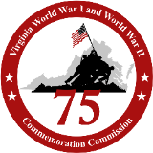
VirginiaWorldWarII.org
VirginiaWorldWarI.org

A Better World Shall Emerge: 75th Anniversary of the End of WWII
I. Background:
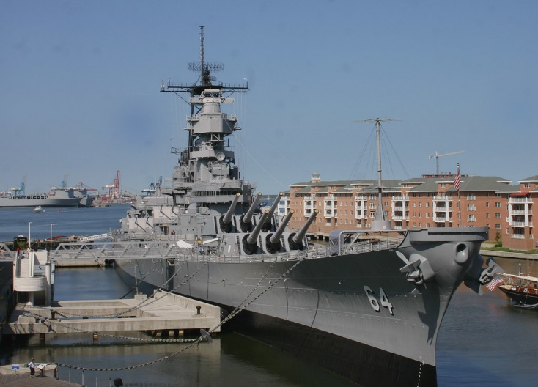
The culminating event in Virginia’s statewide commemoration of the 75th anniversary of World War II will take place on Wednesday, September 2, 2020, as a ceremony held on the deck of the USS Wisconsin in Norfolk. To meet social distancing guidelines, the ceremony will be livestreamed with no audience on site.

The Japanese document of surrender to the Allied Powers was signed on September 2, 1945, at 9:08 a.m. aboard the USS Missouri in Tokyo Bay (BB-63, Iowa class battleship), and was presided over by General Douglas A. MacArthur, Supreme Commander of the Allied Powers. On that Sunday morning 75 years ago, more than 250 Allied warships lay at anchor in Tokyo Bay, as the flags of the United States, Great Britain, the Soviet Union, and China flew above the deck of the Missouri. Following signatures from Japanese officials, Supreme Commander MacArthur signed on behalf of the United Nations, declaring, “It is my earnest hope and indeed the hope of all mankind that from this solemn occasion a better world shall emerge out of the blood and carnage of the past.”
USS Wisconsin, Norfolk

The USS Wisconsin (BB-64, Iowa class battleship), docked in Norfolk at the Nauticus Museum, is a sister ship of the same class as the Missouri, and provides an accurate and powerful location at which to mark the end of the war. Moreover, the MacArthur Memorial has a number of original artifacts from the day, such as the signing pen, MacArthur's copy of the document of surrender, and MacArthur's flag. Working together with partners that include Nauticus, Hampton Roads Naval Museum, MacArthur Memorial, Military Aviation Museum, and U.S. Navy, Virginia's commemoration of the signing of the surrender documents and official end of WWII will draw national attention.

II. Tentative Order of Ceremony
Wednesday, September 2
Commemorative Ceremony - USS Wisconsin / remote sites
9:00 a.m. - Ceremony begins on surrender deck of USS Wisconsin
- Emcee: Greg McQuade, CBS 6
- Opening comments, setting the scene/explaining symbolism
- Reading from MacArthur’s speech (MacArthur interpreter)
- 9:08 a.m. - Ship's horn blows in memory of those who died in WWII, followed by moment of silence and flyover
- Taps from superstructure
- Video montage of 75th anniversary and work of the Commission
- Keynote remarks: Chris Kolakowski, streamed from Wisconsin Veterans Museum
- Brief remarks from historians, dignitaries, to include greetings from remote locations:
- April Cheek-Messier, National D-Day Memorial, Bedford
- Clay Mountcastle, Virginia War Memorial, Richmond
- WWII veterans at Sitter & Barfoot

10:00 a.m. (approx.) - Ceremony concludes

III. Logistics
Production: BVC (Dan Yeary) and WCVE (Craig Keeton) have date locked and can accommodate filming in remote locations. Need to coordinate livestream hosting on web (City/Nauticus/MacArthur Memorial most probable).

Music: Bugler for Taps

Flyover: Military Aviation Museum or U.S. Navy

Equipment rental: TBD as needed

